**Windows Container Deploy,Login,Exit Container**

**Step 1 : Check for the docker information**

# docker info

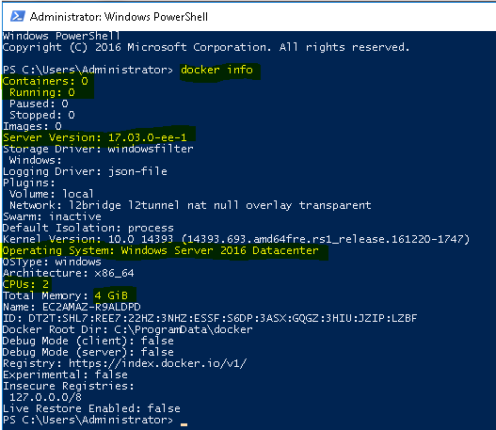

**Step 2 : Check for the available Images**

# docker images



**Step 3 : Search for the Microsoft/iis (On Docker-Hub)**

**// Click on Details**

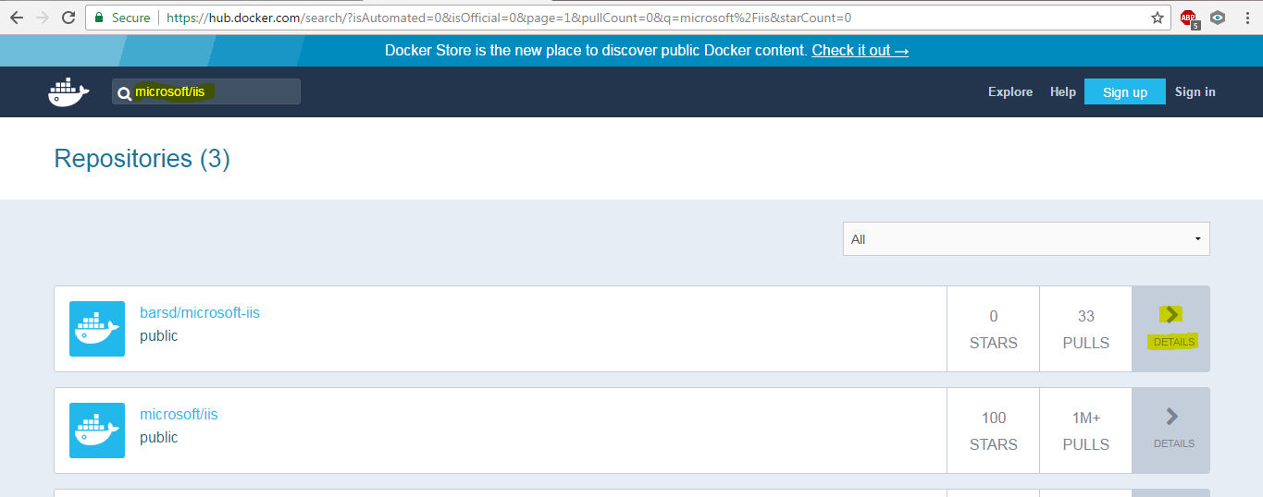

**Step 4 : Copy the mircosoft/iis commands**

# // Copy the Commands

*.*

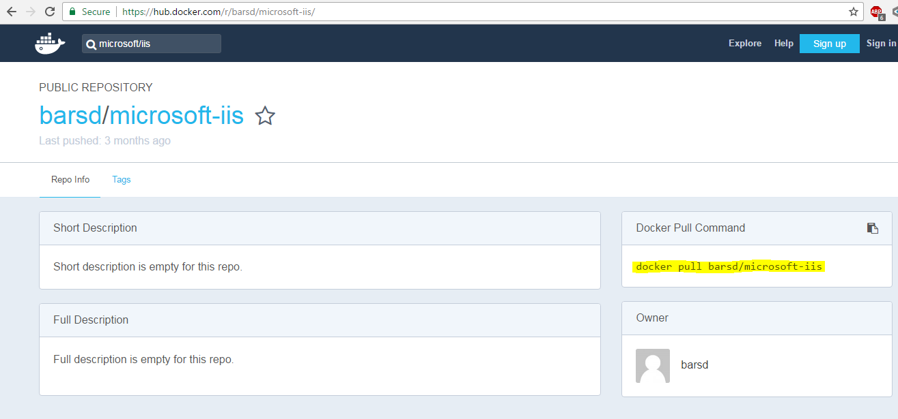

**Step 5 : Pull the Microsoft image form Docker-Hub**

# docker pull microsoft/iis

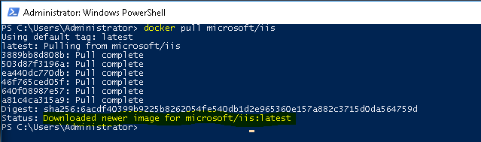

**Step 6 : Verfiy for the Microsoft images**

# docker images



**Step 7 : Now run the container(& map the port 80:90)**

# docker run -i -td -p 90:80 microsoft/iis cmd



**Step 8 : Now Check for the running Containers**

# docker ps

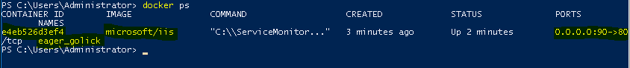

**Step 9 : Login to the container**

# docker exec -it e4eb526d3ef4 cmd

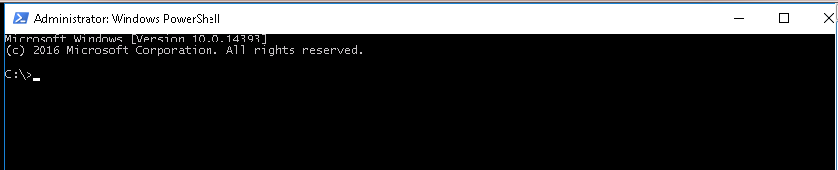

**Step 10 : Check for the hostname(& exit from the containers)**

# hostname

# exit

# exit

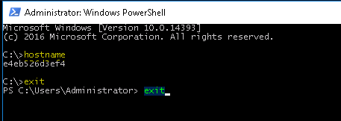

**Wind 2019 – docker Enterprise edition on Google cloud**

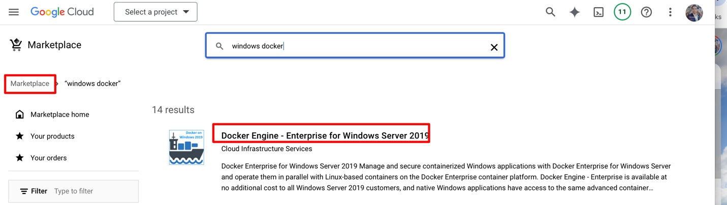

docker pull mcr.microsoft.com/dotnet/samples:dotnetapp

docker run -it --rm -p 8000:8080 --name aspnetcore_sample mcr.microsoft.com/dotnet/samples:aspnetapp